**Exercise 3: Stored Procedures**

**Scenario 1: The bank needs to process monthly interest for all savings accounts.**

**PL/SQL Code:**

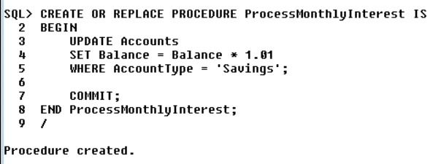

**Output:**

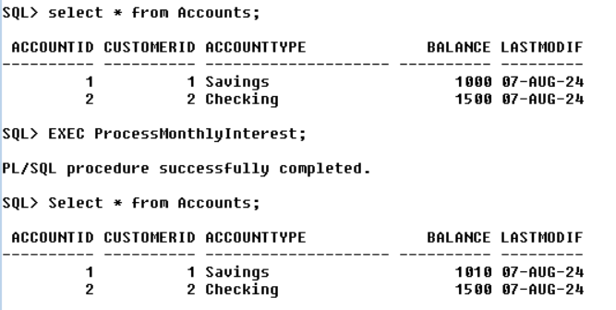

**Scenario 2: The bank wants to implement a bonus scheme for employees based on their performance.**

**PL/SQL Code:**

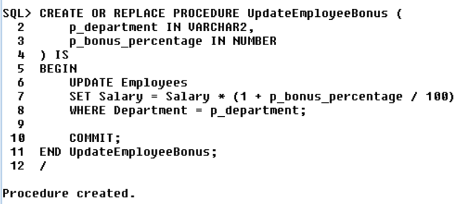

**Output:**

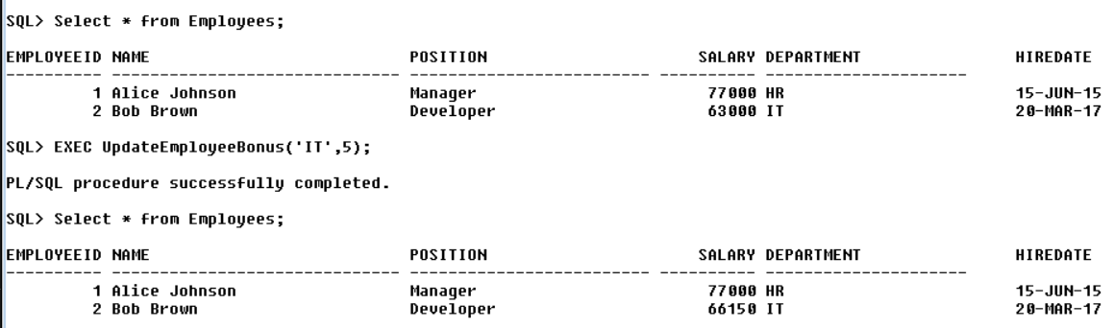

**Scenario 3:** **Customers should be able to transfer funds between their accounts.**

**PL/SQL Code:**

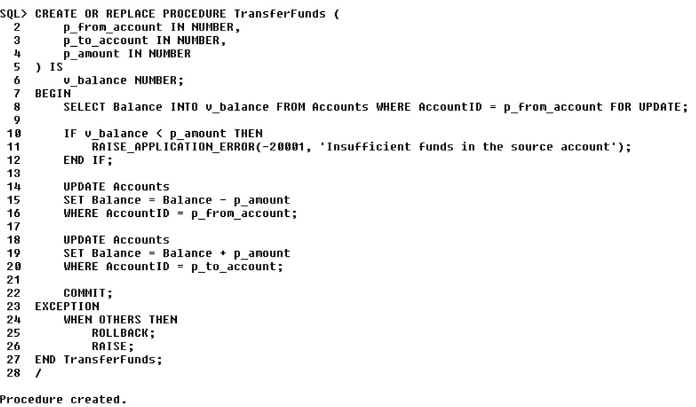

**Output:**

